Calibration of the Holographic Working Memory Toolkit using the Delayed Saccade Task
Grayson M. Dubois
It is ironic that the human brain is the powerhouse of all knowledge and learning humans are capable of, yet our knowledge of its function and complexity is barely a fraction of its full capability. We are only just beginning to learn the complexities of arguably our most intricate organ. We can learn much more, however, using artificial neural networks (ANNs). ANNs is the subfield of artificial intelligence (AI) that employs an approach to engineering machine learning systems based on biological brain systems. Because ANNs are based on biological systems, they serve as formal, testable hypotheses of brain function and learning in the cognitive sciences. One limitation of ANN models is that they often use distributed encoding (DE) of the concepts involved within the models, which limits their capabilities in areas of AI that typically use symbolic encoding (SE), such as planning, reasoning, and robotics.
Our research focuses on a system of the brain known as working memory (WM). WM is used when a person performs a task for which they require a small amount of information for a short period of time. WM maintains a few task-essential facts until they are utilized, at which point they are overwritten with new information. WM is thought to be composed of the prefrontal cortex and mesolimbic dopamine systems in humans and animals, and ANNs based on WM have been designed based on electrophysiological, neuroimaging, and neuropsychological studies [1]. Through these systems, WM supports transferable learning, limits the search space for perceptual systems, overcomes the out-of-sight/out-of-mind problem, as well as more [2, 3]. The Working Memory toolkit (WMtk) is a software library that is used to provide a framework for building a WM-based ANN for robotic systems using a DE interface [4].
Because the WMtk houses an ANN that uses DE, its integration into other SE-based AI systems is difficult to achieve in practice. This is because DE/SE conversion has to be programmed directly by the user, which is a difficult task even for anyone not an expert in this area of research. There is a technique, however, called holographic reduced representation (HRR) [5] that can overcome these limitations. HRRs are a method of creating and combining symbolic concepts using an ANN compatible distributed formalism. I have replaced the DE interface of the WMtk with an HRR interface, thus automating the DE/SE conversion, and opening the door to new capabilities for the augmented toolkit, such as task generalization, chunking, hierarchical tasks, and more.
In an earlier URECA-funded research project, I wrote a software engine in C++ - the HRR Engine (HRRE) – which manages the representation and manipulation of concepts using HRRs. The HRRs allow this engine to automate the DE/SE conversion in the WMtk, thus vastly reducing the amount of preparation work that users are required to do to represent concepts used in learning tasks written using the toolkit. I have also rewritten the Working Memory toolkit from the ground up to utilize the HRRE. However, the new Holographic Working Memory toolkit (HWMtk) has yet to be tested and calibrated on a suitable task involving working memory to ensure that it correctly performs such learning tasks and can be published for use by future researchers.
The task we have chosen to use to test the HWMtk is the Delayed Saccade task (DST). In the DST, a participant (AI software and/or robot) is required to focus attention on a crosshair in the center of a computer screen. After a variable time delay, a target object will appear in the periphery of the screen, but the agent must continue to focus on the crosshair in the face of this distraction. After some time, the target object disappears and the agent must continue to focus on the crosshair. Finally, the crosshair disappears and the agent must then look at (or saccade to) the location where the target object appeared during the task. Rather than programming the agent to solve the DST, the WMtk allows the agent to learn how to solve the DST by repeatedly attempting the task as a series of episodes. The agent's WM learns to both override automatic behaviors (such as immediate saccades) and store task relevant information (such as target locations) in order to guide future actions. Importantly, the agent is given feedback (positive reward) only at the very end of correctly performed episodes. Even under these conditions, the WMtk learned to correctly manage items in WM and attain proficiency on the DST within just hundreds of episodes.
We chose this task for several reasons. First, the delayed saccade task (DST) is a good example of how working memory is used in cognitive learning tasks and was the main task that Phillips and Noelle used to demonstrate the original Working Memory toolkit [6]. Therefore, we already have the source code for the DST. However, the code will need to be refactored for this project by replacing the original DE interfacing modules with new SE interfacing modules which are compatible with the HRRE and, by extension, the HWMtk. In particular, this refactoring will involve removing the old functions dealing with encoding DE representations and replacing them with the symbol-based SE interface utilized by the HWMtk. Finally, using the DST allows us to directly compare the performance between the original and augmented toolkits. Therefore, our specific aim is to calibrate the HRR-augmented WMtk with the DST, and compare its performance with that of the original toolkit. The result of this project will be that the HWMtk will be ready for release to the cognitive science and ANN communities for further use in WM-based research.
Work on this project will consist of three phases:
1) Altering the DST source code. I currently have access to the source code for the DST test designed for the original WMtk. I will remove the code that handles the construction of DE representations to pass to the toolkit, and replace it with the SE passing interface for the HWMtk. The HWMtk can then take the SE representations of the environment and manage the DE/SE encoding and decoding of the SE representations automatically.
2) Testing and calibrating the HWMtk. Phase two consists of two tasks which I will perform concurrently: testing the toolkit with the DST, and calibrating it for better performance. After the DST code has been updated for compatibility with the augmented toolkit, I will run tests using both the new HWMtk-DST code and the original WMtk-DST. First, I will test to see if the HWMtk-DST agent can effectively encode and decode concepts related to the DST. This will involve checking for unexpected activity, inefficient performance, failure to learn, or other abnormal activity. I will also be making alterations and adjustments to the code to ensure that the agent behaves how we would expect. During the testing, I will check for extreme discrepancies between the original and new tests, such as an increase in the number of episodes taken to learn the task and sensitivity to various model parameters including the network learning rate, future reward discounting factor, and past action eligibility factor.
3) Gather data to compare the performance of the original augmented toolkits. When I am satisfied with the behavior of the agent using the augmented toolkit and DST, I will run the DST using both the WMtk and HWMtk, gathering data on their performance, checking variables such as the number of episodes required to adequately learn the task. I will also compare the ease of use in setting up the simulation code for the HWMtk as compared to before, when the user was required to manually encode the concepts used in the simulation, as this was the original goal of the entire project. Finally, I will compose a manuscript on how the HWMtk toolkit performs on the DST while providing a significant reduction in programmer responsibilities compared to the original WMtk.
Additionally, I plan to submit the final manuscript to and, if accepted, present the results of my work at the Association for the Advancement of Artificial Intelligence’s (AAAI) thirty-first conference in San Francisco in Spring 2017.
By the end of this project, I will have gained experience testing and calibrating scientific code, gathering and analyzing data, and applying machine learning and artificial neural network principals to perform tests related to cognitive science. Finally, I will be submitting a manuscript for peer-review to the AAAI Conference, which will aid writing my undergraduate Honors thesis on our research. All of these will be invaluable skills, as my long-term goal is to pursue a Ph.D in Computer Science. I wish to apply all that I have learned to either research or development of software aimed towards helping and improving the lives of those in need.

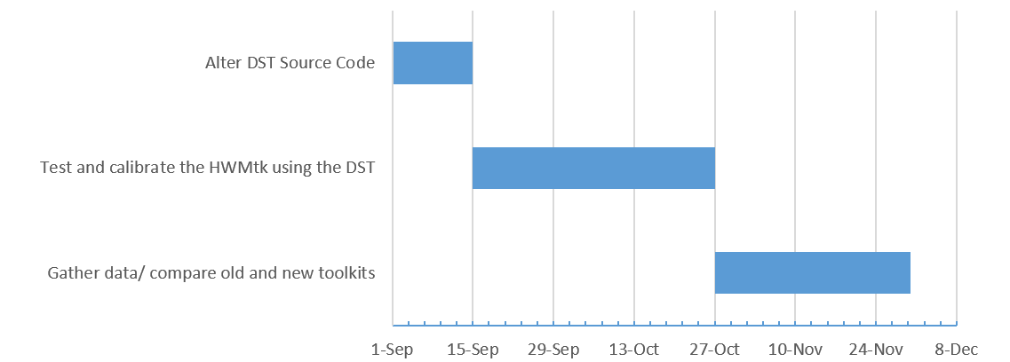
Project Timeline
Figure 1 - Phase 1: Alter DST Source Code (Sept 1 – 21). Phase 2: Test and calibrate the HWMtk using the DST (Sept 21 – Oct 26). Phase 3: Gather data / compare old and new toolkits (Oct 23 – Nov 10).

References:
[1] A. Baddeley. Working Memory, volume 11 of Oxford Psychology Series. Clarendon Press, Oxford, 1986.
[2] N. C. Waugh and D. A. Norman. Primary memory. Psychological Review, 72:89–104, 1965.
[3] R. C. O’Reilly, D. C. Noelle, T. S. Braver, and J. D. Cohen. Prefrontal cortex and dynamic categorization tasks: Representational organization and neuromodulatory control. Cerebral Cortex, 12:246–257, 2002.
[4] J. L. Phillips and D. C. Noelle. Working Memory for Robots: Inspirations from Computational Neuroscience. in Proceedings of the 5th International Conference on Development and Learning, 2006.
[5] T. A. Plate. Holographic reduced representations. IEEE Trans. Neural Networks, vol. 6, no. 3, pp. 623–641, May 1995
[6] J. L. Phillips and D. C. Noelle. A Biologically Inspired Working Memory Framework for Robots. IEEE International Workshop on Robot and Human Interactive Communication, 2005.

